

# Objective

You will install, configure and explore DNS, BIND and dig.

BIND (Berkley Internet Naming Daemon) is the DNS server on Linux.

题外话：root winscp

root免密码

sudo pico /etc/sudoers

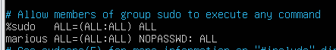

重启



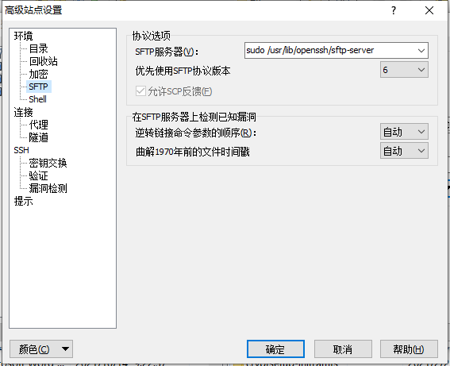

1. **Install BIND**

On the sever,先apt-get update

sudo apt-get install bind9 dnsutils

There are many common ways to configure BIND9. The most common three configurations are:

Caching/forwarder nameserver - it find name queries and remember the answers for later queries.

Primary master nameserver - it reads the data for a zone from a file and is authoritative for the zone.

Secondary nameserver - it gets the zone data from another nameserver that is authoritative for the zone.

Configuration files are stored in the /etc/bind folder. The primary configuration file is /etc/bind

/named.conf.

As a way of verifying that the installation succeeded, have a look at /etc/bind/db.root that describes the root nameservers in the world.

less /etc/bind/db.root

(It might be easier if you just change to the /etc/bind directory for the remainder of this lab)

cd /etc/bind

In this lab, we can setup a caching nameserver and a primary master nameserver.

1. **Set up a cache/forwarder nameserver**

sudo pico /etc/bind/named.conf.options

Under options, uncomment the section about forwarders and edit it to look like this:

forwarders {

202.119.24.18; # SEU DNS

8.8.8.8; # Google Public DNS

};

Note: Punctuation is of crucial importance in DNS configurations! Be very careful to match the supplied configs, especially where full stops are involved.

Save the file.

Now restart the bind9 service.

sudo service bind9 restart

Let us test by querying the often mistyped uniseu.edu (that is, no trailing .au):

dig uniseu.edu

If you don’t specify the type of record you desire be returned, then dig will respond with the A record (if it exists).

You should see an answer, but with a large *Query Time* value (in the hundreds of milliseconds).

Wait 5-10 seconds and run the query again. Now what value for Query Time do you see?

It should be significantly lower now ( ≈ 10 milliseconds is typical) since this is a cached result.

若您并没有指定要返回的记录类型，那个么dig将用一条记录（若它存在）进行响应。

您应该会看到一个答案，但是查询时间值很大（以数百毫秒为单位）。

等待5-10秒，然后再次运行查询。现在您看到查询时间的值是多少？

现在应该会大大降低（≈ 通常为10毫秒），因为这是一个缓存结果。

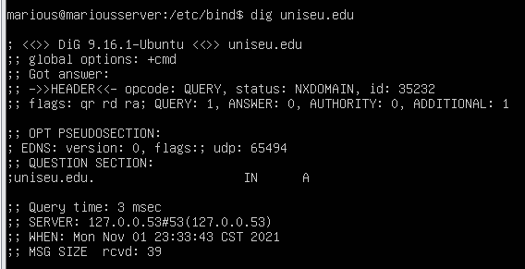

1. **Set up static IP for VMs背水一战**

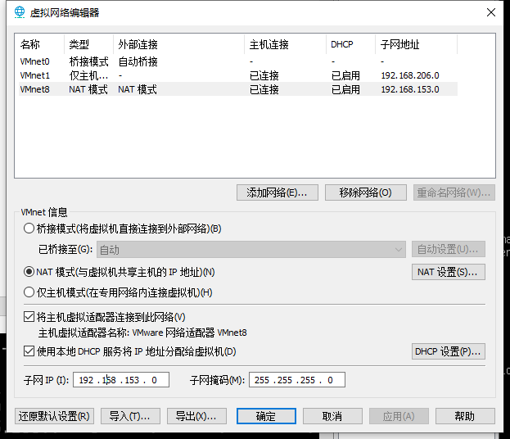 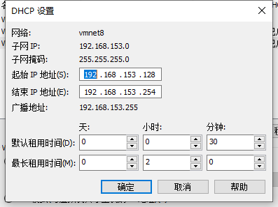

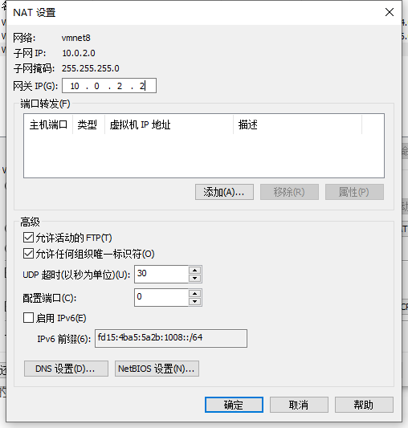**改成10.0.2.1，tmd**

Find out the LAN router (gateway) IP. On the server,

route -n

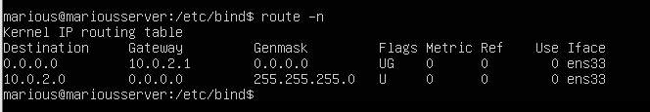

The gateway is likely to be 10.0.2.1.

Setting the *server*'s IP to 10.0.2.100. On the server 00那个吧应该是（20.04版本

sudo pico /etc/netplan/00-installer-config.yaml

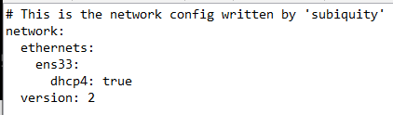

under the interface enp0s3, remove the dhcp4 line and modify the content to:

ethernets: enp0s3:

addresses:

- 10.0.2.100/24

gateway4: 10.0.2.1 nameservers:

addresses: [10.0.2.100] optional: true

version: 2

Save the file and apply the new configuration:

sudo netplan apply

Setting the *desktop*'s IP to 10.0.2.200. On the desktop, click at the network icon at the top-right corner then select Wired Connected -> Wired Settings . Under Wired, click at the setting icon

(gear) then IPv4 tab. Under IPv4 Method, tick manual. Put the following in the form:

将桌面的IP设置为10.0.2.200。在桌面上，单击右上角的网络图标，然后选择有线连接->有线设置。在“有线”下，单击设置图标（齿轮），然后单击IPv4选项卡。在IPv4方法下，勾选手动。将以下内容填写在表格中：

Address: 10.0.2.200

Netmark: 255.255.255.0

Gateway: 10.0.2.1

DNS: 10.0.2.100

Turn the *Automatic* off under DNS.

Then press the Apply button. Now turn the Wired off and on again to pick up the new configuration. You close the network settings.

然后按下应用按钮。现在，再次关闭和打开有线电视，以选择新配置。您可以关闭网络设置。

1. **Set up zone files for the marious.test domain**

(We are going to set up an RFC2606 ".test" domain here. This is unavailable to the wider internet by design.)

我们将在这里设置一个RFC2606“.test”域。从设计上看，这在更广泛的互联网上是不可用的。

On the *server*,

sudo pico /etc/bind/named.conf.local

localhost正向区文件，用于将名字localhost转换为本地回送IP地址 (127.0.0.1)

Add the following lines to that file:

zone "marious.test"{ type master;

file "/etc/bind/db.marious.test";

};

zone "2.0.10.in-addr.arpa" { type master;

notify no;

file "/etc/bind/db.10";

};

Save the file.

复制

sudo cp /etc/bind/db.local /etc/bind/db.marious.test

And edit the new **forward zone file**.

并编辑新的前进区域文件。

sudo pico /etc/bind/db.marious.test

Most importantly you must change the serial number in the SOA appropriately. I highly encourage the use of dates followed by a 2 digit count for the day: YYYYMMDD01. But also you will need to add A records for new hosts, CNAMEs for aliases and some other details in red.

Modify the file as follows:

;

; BIND data file for local loopback interface

;

$TTL 604800

@ IN SOA server.marious.test. asl.seu.edu.cn.(

2019112001 ; Serial

604800 ; Refresh

86400 ; Retry

2419200 ; Expire

604800 ) ; Negative Cache TTL

;

@ IN NS server.marious.test.

@ IN A 127.0.0.1

@ IN AAAA ::1

gateway IN A 10.0.2.1

server IN A 10.0.2.100

desktop IN A 10.0.2.200

dns IN CNAME server

www IN CNAME server

;

; This is the forward zone for marious.test internal domain ;

;

$TTL 604800

|  |  |  |  |  |
| --- | --- | --- | --- | --- |
| @  ; | IN | SOA server.marious.test. asl.seu.edu.cn. ( 2019112001 ; Serial  604800 ; Refresh  86400 ; Retry  2419200 ; Expire  604800 ) ; Negative Cache TTL | | |
| @ | IN | NS server.marious.test. | | |
| @ | IN | A 127.0.0.1 | | |
| @ | IN | AAAA ::1 | | |
| gateway | | IN | A | 10.0.2.1 |
| server | | IN | A | 10.0.2.100 |
| desktop | | IN | A | 10.0.2.200 |
| dns | IN | CNAME | | server |
| www | IN | CNAME | | server |

Similarly for the **reverse zone file**:

sudo cp /etc/bind/db.127 /etc/bind/db.10

And edit the new file appropriately:

sudo pico /etc/bind/db.10

Modify the file as follows:

;

; BIND reverse data file for local loopback interface

;

$TTL 604800

@ IN SOA server.marious.test. asl.seu.edu.cn. (

2019112001 ; Serial

604800 ; Refresh

86400 ; Retry

2419200 ; Expire

604800 ) ; Negative Cache TTL

;

@ IN NS server.marious.test.

1 IN PTR geteway.marious.test.

100 IN PTR server.marious.test.

200 IN PTR desktop.marious.test.

;

; This is the reverse zone for marious.test. internal domain ;

$TTL 604800

@ IN SOA server.marious.test. asl.seu.edu.cn. ( 2019112001 ; Serial

604800 ; Refresh

86400 ; Retry

2419200 ; Expire

604800 ) ; Negative Cache TTL

|  |  |  |
| --- | --- | --- |
| ;  @ | IN | NS server.marious.test. |
| 1 | IN | PTR gateway.marious.test. |
| 100 | IN | PTR server.marious.test. |
| 200 | IN | PTR desktop.marious.test. |

And restart the bind9 service.

sudo service bind9 restart

Check your DNS configuration on the *server*:

sudo named-checkconf

sudo named-checkzone marious.test db.marious.test sudo named-checkzone 2.0.10.in-addr.arpa. db.10

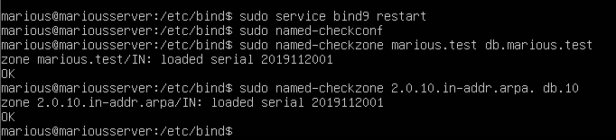

Restart both server and desktop VMs for them to pick up the new configuration.

1. **Test your DNS for the marious.test domain on the *server***

Test the forward zone

dig desktop.marious.test

You should have:

;; ANSWER SECTION:

desktop.marious.test. 604800 IN A 10.0.2.200

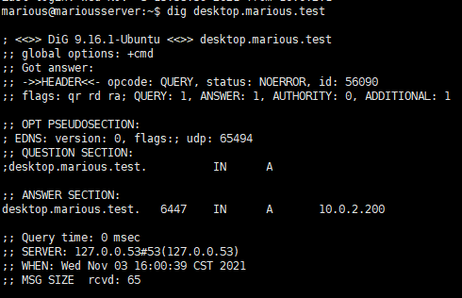

You can query the master nameserver by specifying the DNS:

dig desktop.marious.test @server.marious.test

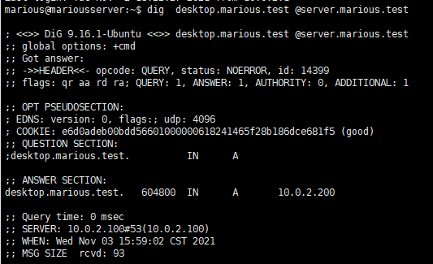

Then you should have:

;; ANSWER SECTION:

desktop.marious.test. 604800 IN A 10.0.2.200

;; AUTHORITY SECTION:

marious.test. 604800 IN NS server.marious.test.

Test the reverse zone

dig -x 10.0.2.200 @server.marious.test

You should have:

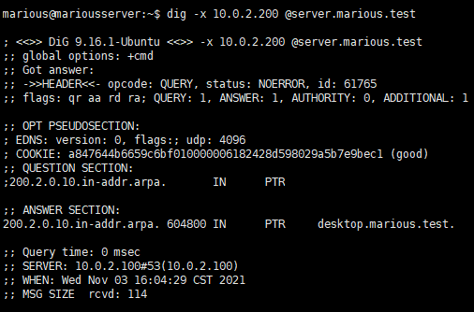

;; ANSWER SECTION:

200.2.0.10.in-addr.arpa. 604800 IN PTR

desktop.marious.test.

;; AUTHORITY SECTION:

2.0.10.in-addr.arpa. 604800 IN NS server.marious.test.

1. **Access your Dokuwiki using a hostname on the *desktop***

On the desktop, start the browser and point it to: [www.marious.test/dokuwiki.](http://www.abc123.test/dokuwiki)

Bookmark it for later use.

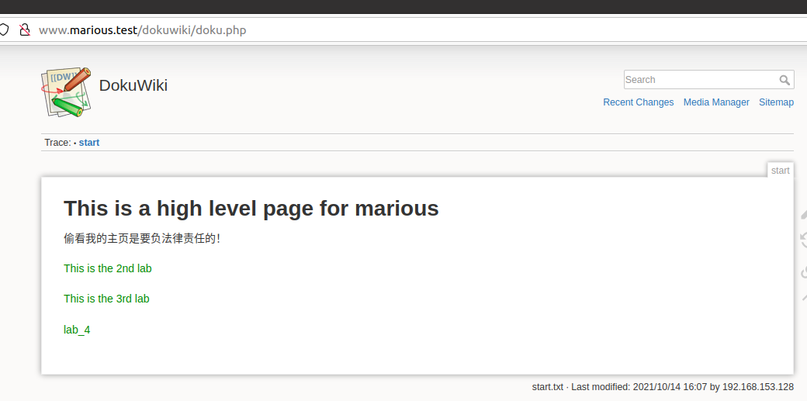

1. **Other useful dig commands**

Lookup an address from a specific DNS server

dig @seic8.seu.edu.cn [www.seu.edu.cn](http://www.seu.edu.cn/)

A reverse lookup (address to name): This is not guaranteed to be present and configured on all name servers.

dig -x 121.248.60.55

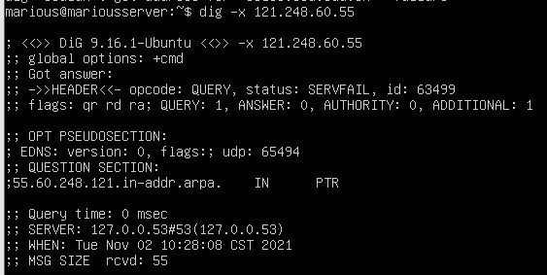

Look for a specific type of record, e.g. MX

dig -t MX seu.edu.cn

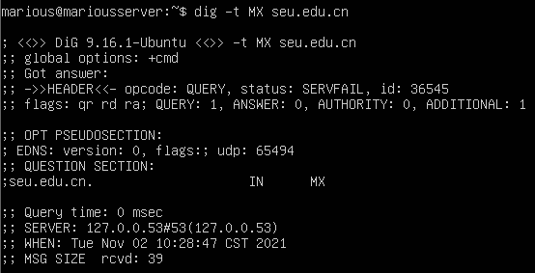

What is the name of the front SEU Mail host (internally)?

# Submission and mark

For full marks today, show your teacher

1.5 mark for demonstrating the cache/forwarder nameserver working;

1.5 mark for demonstrating forward lookups working;

1.5 mark for demonstrating reverse lookups working;

1.5 mark for accessing your Dokuwiki using the server's hostname.

You should be ready to answer any questions to demonstrate that all work is done by yourself otherwise you may receive 0 mark.

IMPORTANT NOTE: You will need to document all of your lab work in your wiki.